Heavy Weight #9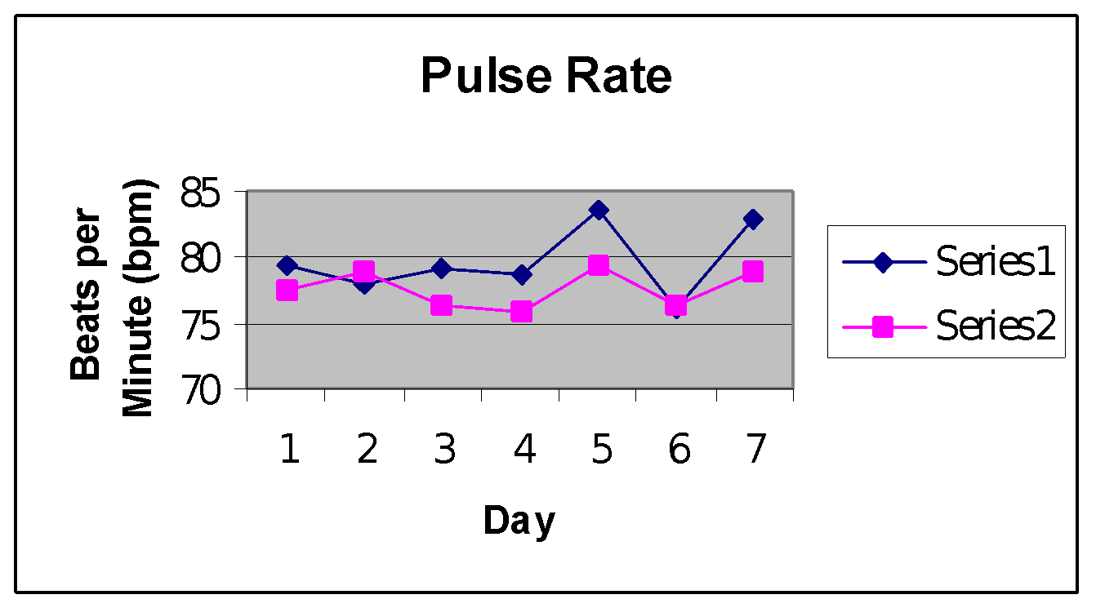

**Series #1 w/o strip; Series #2 w/ strip**

# Series #1 mean: 77.544 bpm; Series #2 79.7718 bpm

The Series #2 mean has a .0798 probability of occurring by chance when compared to the mean in Series #1. This shows strong evidence that the nasal strip decreased the subject’s pulse rate.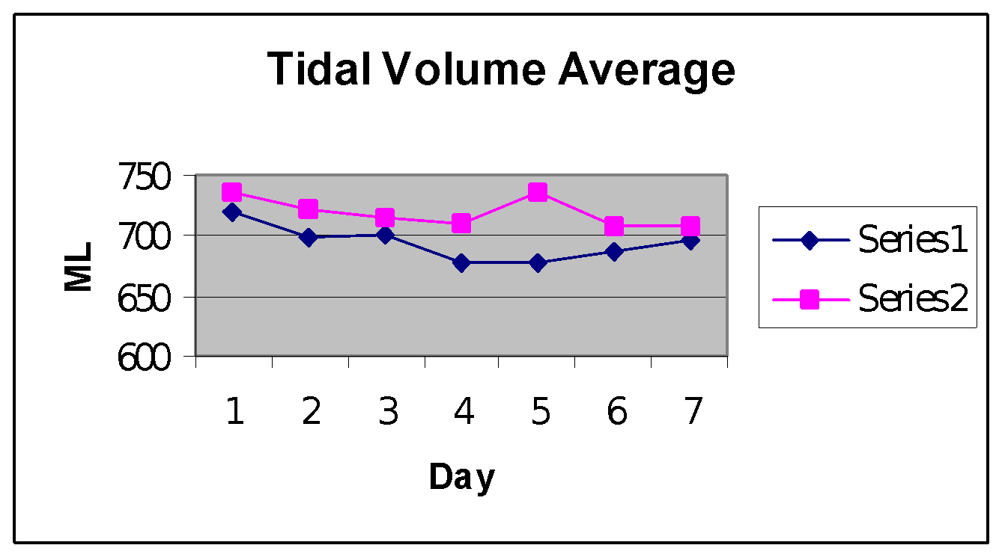

Series #1 mean: 696.1683 ml; Series #2 mean: 719.228 ml

The Series #2 has less than a .001 probability of occurring by chance when compared to the Series #1 mean. This gives strong evidence that the nasal strip increased tidal volume of the subject.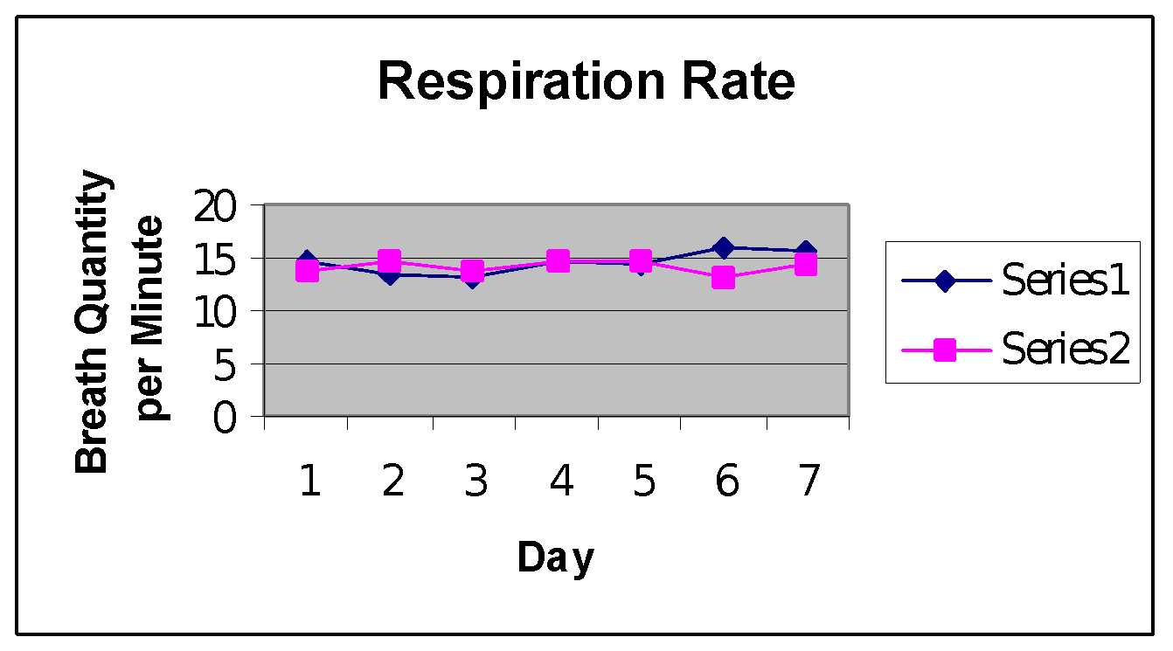

Series #1 mean: 14.5441 bqpm; Series #2 mean: 14.061 bqpm

The Series #2 mean has a .089 probability of occurring by chance when compared to the Series #1 mean. This gives strong evidence that the nasal strip decreased the subject’s respiratory rate.

Series #1 mean: 303,752.055 ml; Series #2 mean: 305,549.63 ml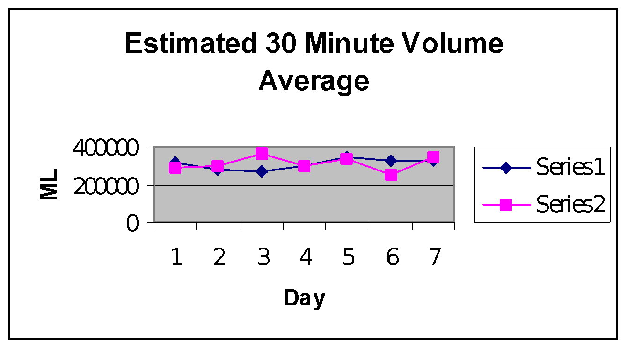

The Series #2 mean has a .9472 probability of occurring by chance when compared to the Series #1 mean. This shows weak evidence that the nasal strip either increased or decreased the subject’s 30 minute volume.